Andre Hardy – Module 3 Lab Assessment

A Wireless Access Point (WAP) is a networking hardware device that allows a Wi-Fi-enabled device to connect to a wired network. It acts as a bridge between wired and wireless networks, enabling devices like laptops, smartphones, and tablets to access the network without the need for physical cables. WAPs facilitate the creation of Wi-Fi networks, providing a means for devices to communicate wirelessly.

Purpose of a Wireless Access Point:
The primary purpose of a WAP is to enable wireless connectivity by allowing devices to connect to a local area network (LAN) or the internet without the need for physical cables. WAPs are also used to extend the coverage of a wired network, providing flexibility for users to connect from different locations within the range of the wireless signal. WAPs centralize access control and security settings, allowing network administrators to manage and secure the wireless network more effectively.

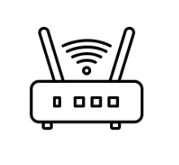

Antennas:
Antennas are crucial components of wireless communication systems that transmit and receive radiofrequency signals. In the context of wireless networking, antennas play a key role in facilitating the communication between wireless devices and access points. Antennas transmit and receive radiofrequency signals that carry data between wireless devices and access points. The design and orientation of antennas impact the range and coverage of the wireless network. Directional antennas focus the signal on a specific direction, while omnidirectional antennas radiate the signal in all directions. Antennas influence the quality of the wireless signal, including factors like signal strength and reliability.

Association Process:
The association process is the sequence of steps that a wireless device goes through to connect to a wireless network through a wireless access point. The process involves the following key steps:

- Scanning: The wireless device scans for available wireless networks and identifies the Wireless Access Points (WAPs) within its range.

- Authentication: The device authenticates itself to the WAP, typically using a pre-shared key (WPA/WPA2) or other authentication methods.

- Association: Once authenticated, the device associates with the WAP, establishing a connection and obtaining an IP address from the network.

- Configuration: The WAP and the device negotiate parameters such as data rate, encryption method, and other settings.

- Connection: Upon successful completion of the association process, the wireless device is connected to the wireless network, and data can be transmitted and received.

The association process is crucial for securing and managing the connections on a wireless network. It ensures that only authorized devices can access the network and that communication is established in a secure and efficient manner.

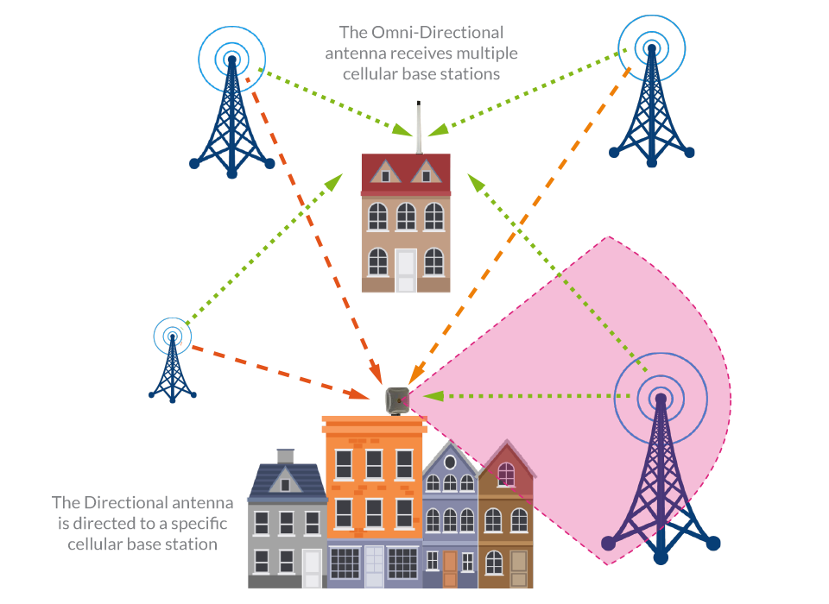

References:
“ The difference between Directional and Omni-Directional Antennas” 17 Sep 2019 NetXL Distribution Ltd.
https://www.netxl.com/blog/networking/directional-or-omni-directional-antennas/

